***Operating Systems***

***Project Proposal***

***Name = Poorab Gangwani***

***Class = 4B1***

***Roll-Number = CS191092***

***Project Title***

***Different Types of Process Scheduling***

Description:

In my Project , I will Discuss and Demonstrate the Scheduling of various CPU processes by the methods by which work is assigned to resources that complete the work.

Various Processing Algorithms will be Implemented in my Project and **Some** of them are as follows.

1. **Longest Job First (LJF)**

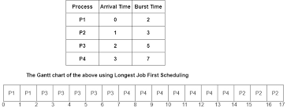

1. **Multi-Level Queue Scheduling(MLQ)**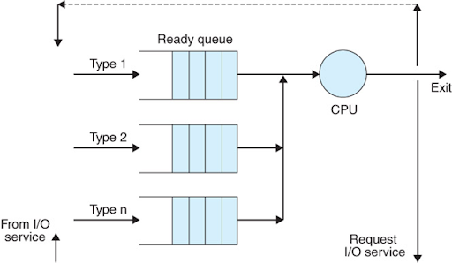

**And Various Other different Processing Algorithms will be explored in my Project Subject.**

**Processing Algorithms to be Implemented will be:**

1. **Longest Job First (LJF)**
2. **Longest Remaining Time First(LRTF)**
3. **Highest Response Ratio Next (HRRN)**
4. **Multi-Level Queue (MLQ)**
5. **Multi-Level Feedback Queue (MLFQ)**

**Tools and Technology**

This Project will be developed in the C++ Programming language using DEV-C++ IDE and the Header file IOSTREAM.